**AWS ROOT PASSWORD RECOVERY**

* I forgot the root password for the instance.
* So I can recover the root password in AWS instance.
* I will launched the two instances .

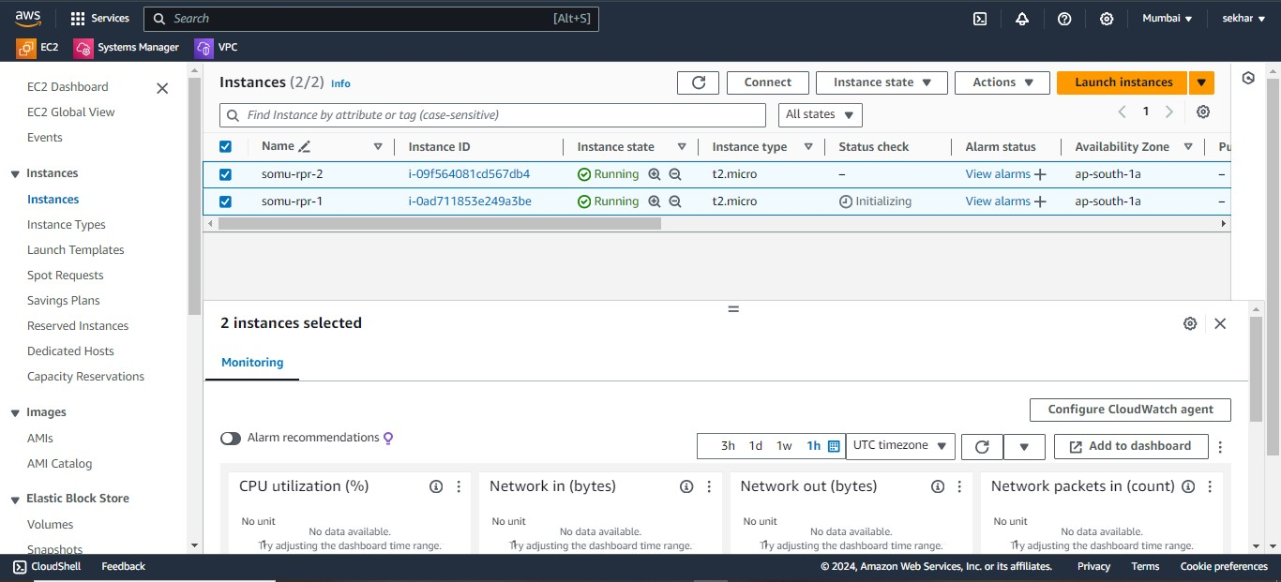

* By using these instances we can login to the putty

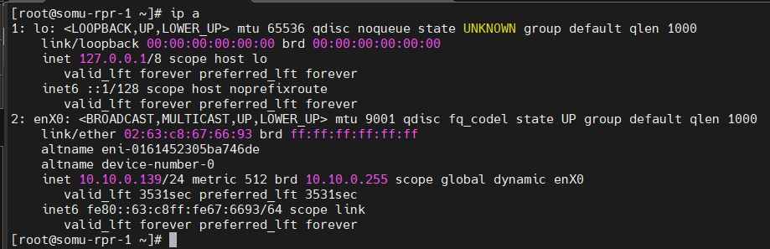

* After launching the instances we can check the server ip

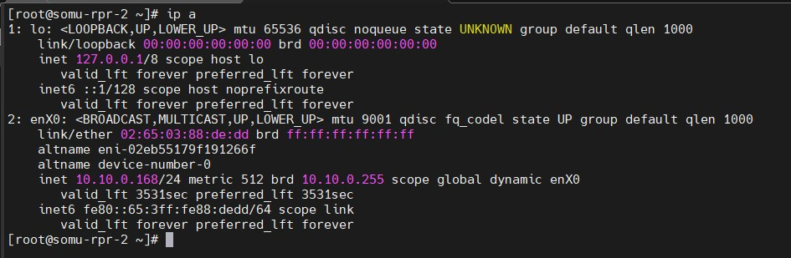

* Now you can see the particular os-volumes in volumes option .

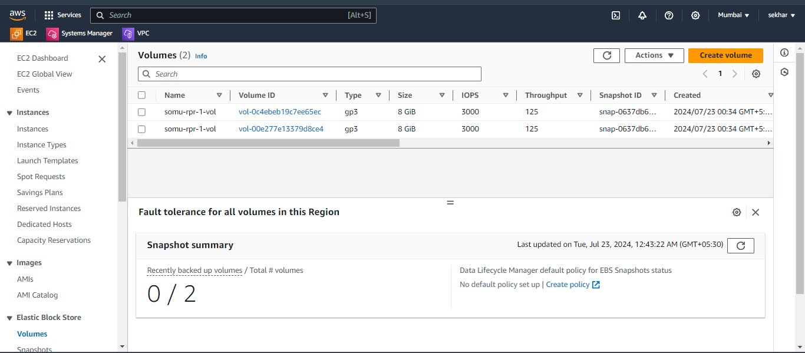

* First we can stop the instance by using click instance state option

After that selection of stop instance then click it then automatically instance will be stopped .

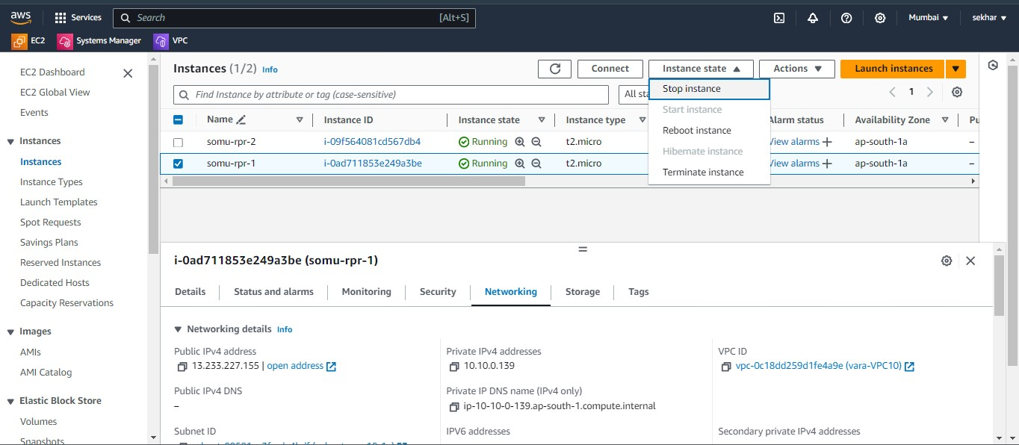

* Now we can see the instance state the instance was stopped successfully

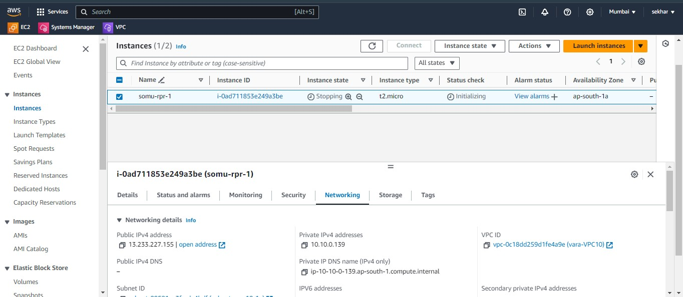

* Then go to volume select the setting and first instance volume will be detach volume.

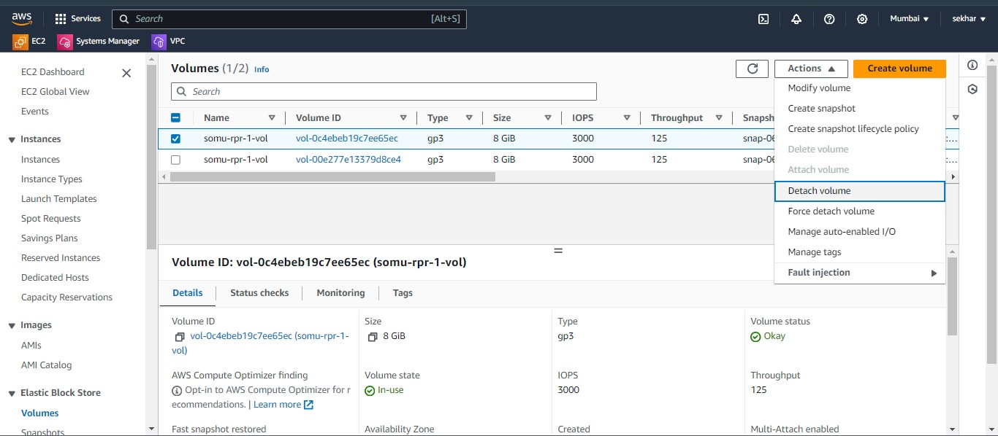

* The volume was successfully detached

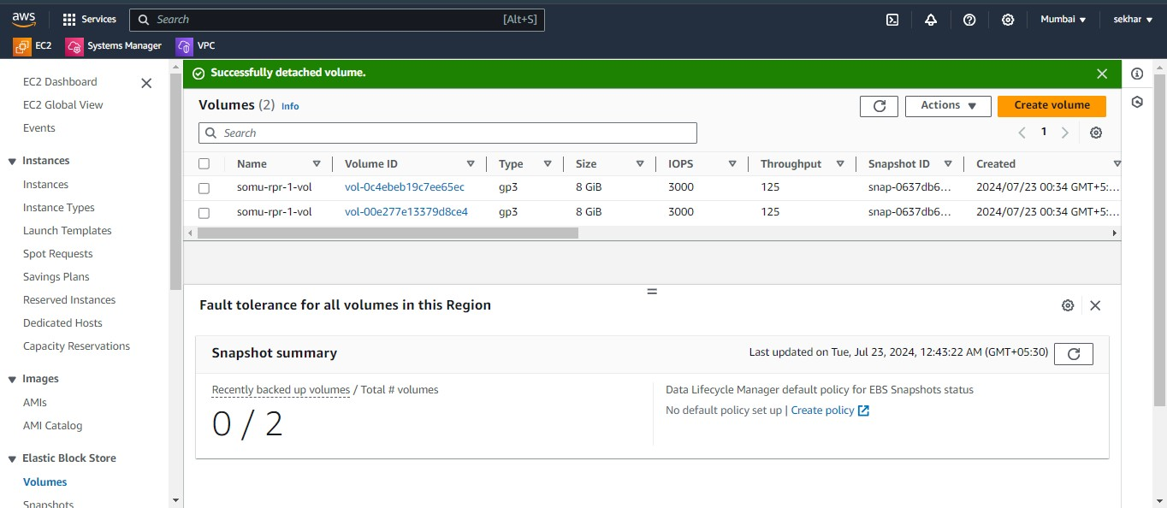

* In these and then attach the second instance volume.

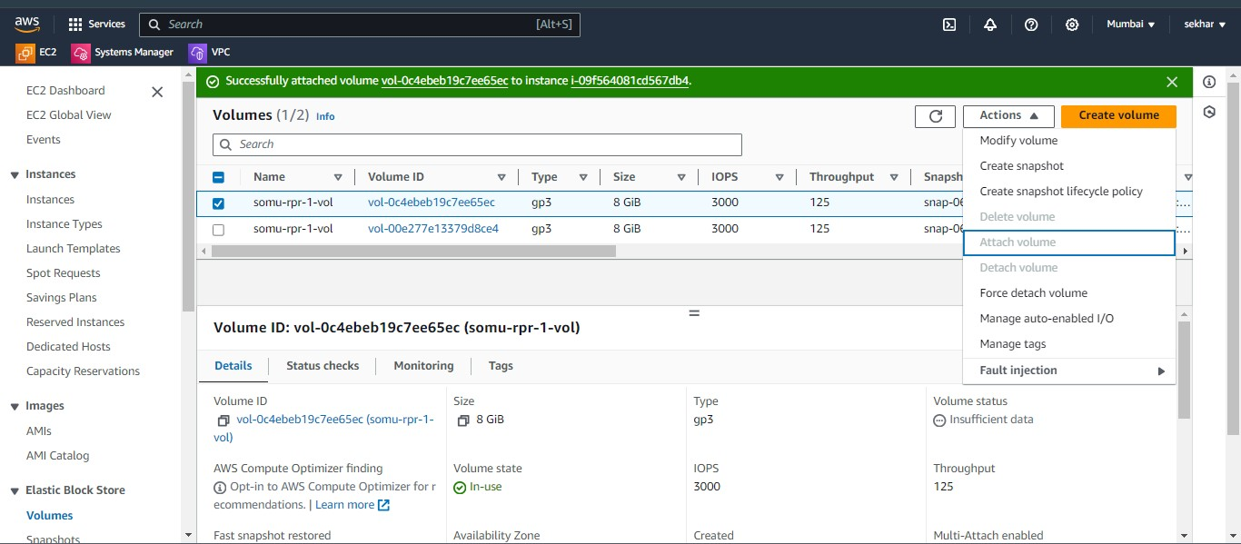

* To given the some entries like.then attath the volume.
* Then go to the volume attachments info and we can select the instance id and device name .

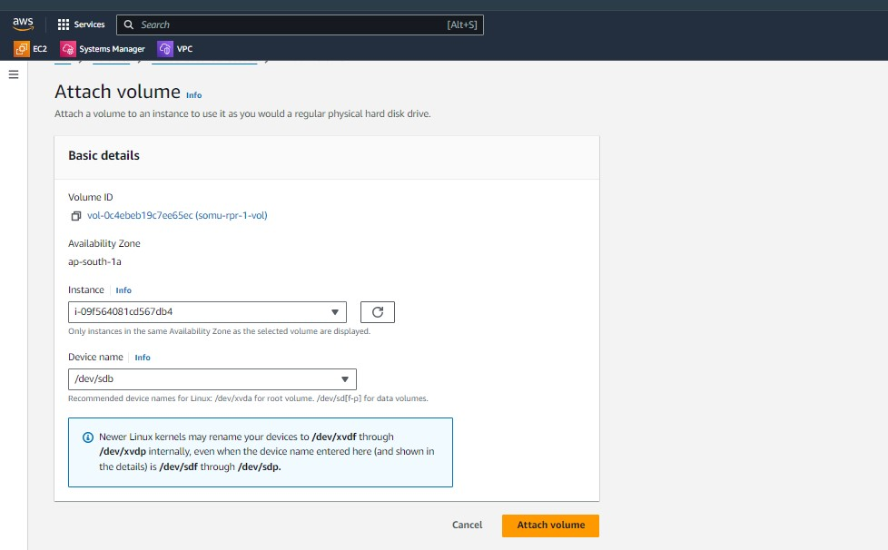

* Successfully attach the first instance.

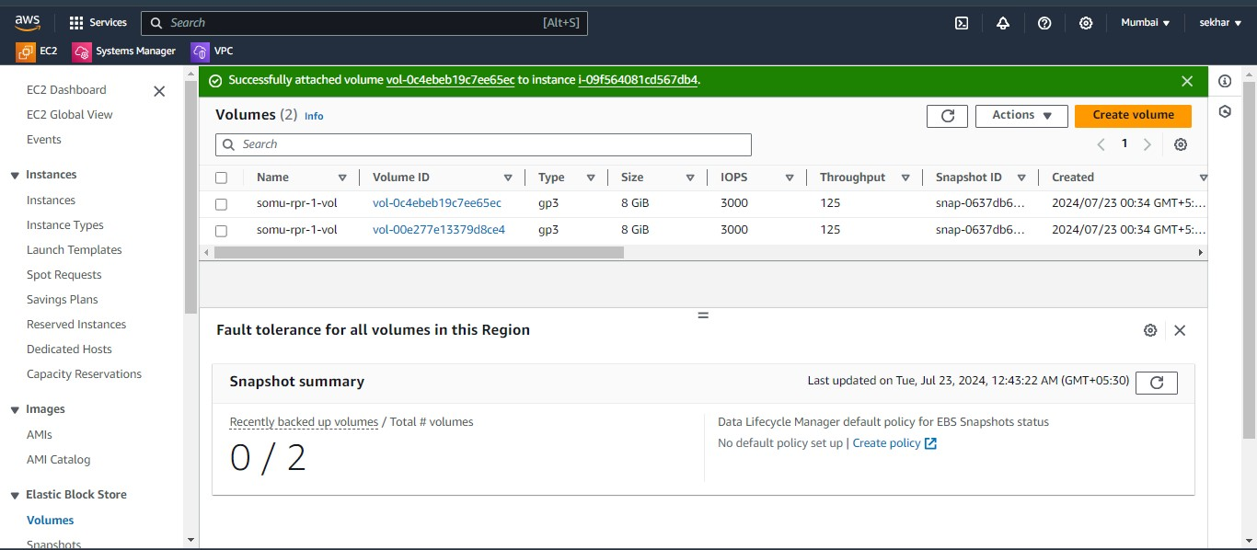

* Just connecting to the putty and check disks.
* By using the command lsblk.

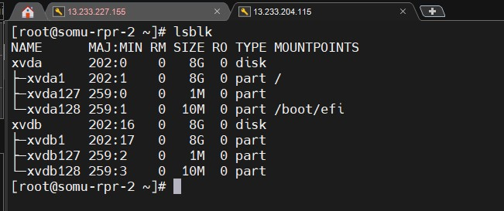

* Then mount the fs to tempory mount point /mnt.

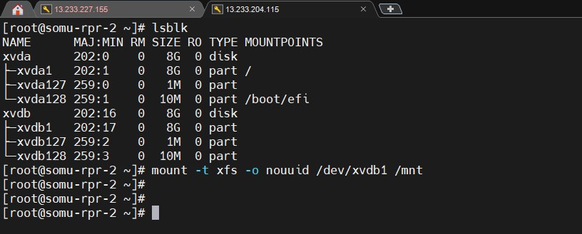

* Create some user and password will be identified to first instance root password to give.

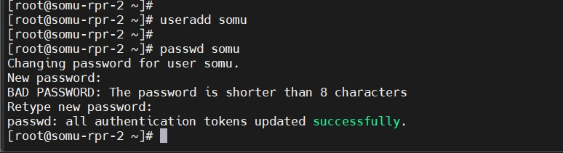

* To copy the in these specified user password in /etc/shadow.

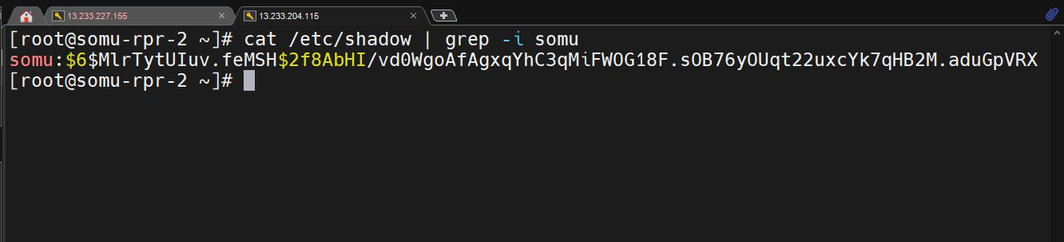

* Copy the encrypted password go to /mnt/etc/shadow.
* To change root password deleted and paste the encrypted password.
* Then save it.

After that unmount the fs.

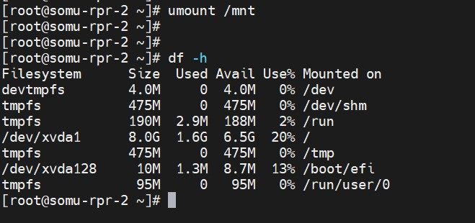

* After the volume detach volume.

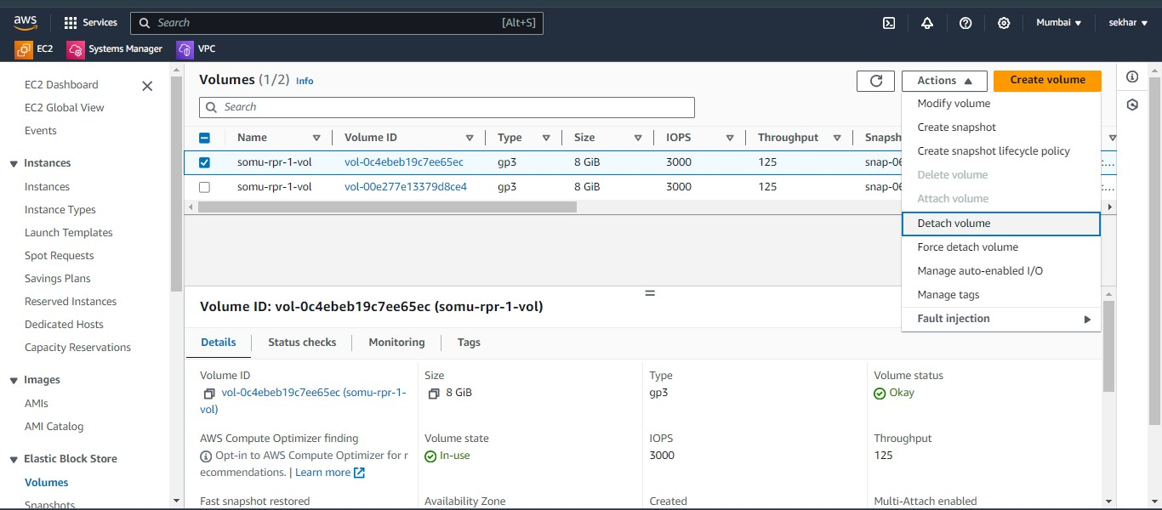

* Successfully detach volume.

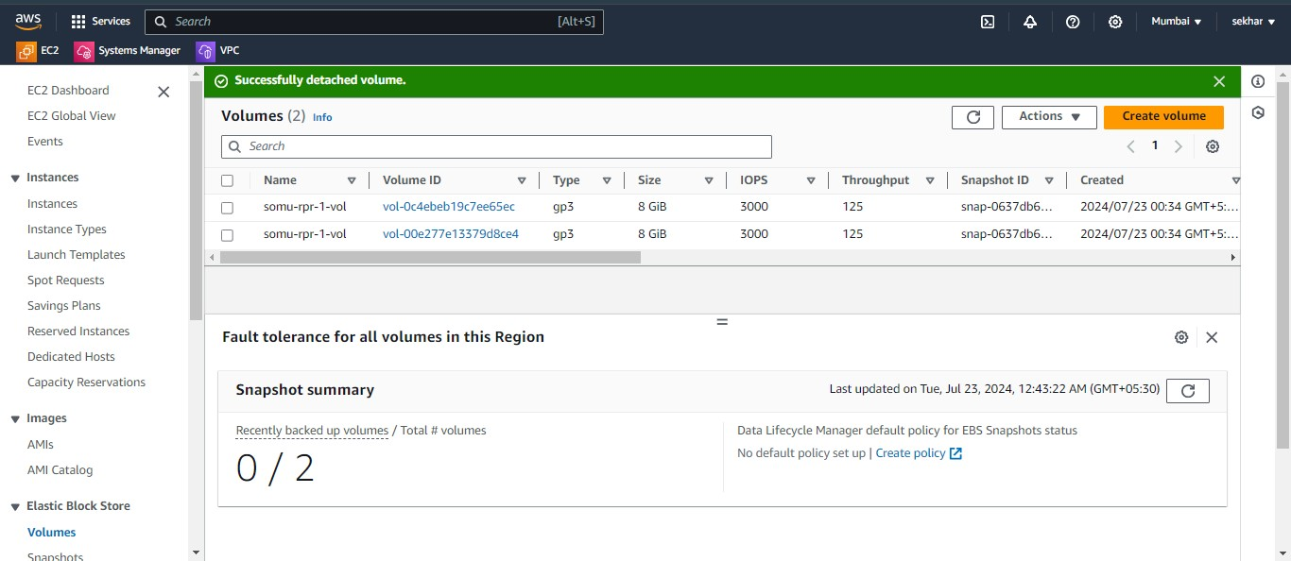

* And then attach volume to 1st instance.
* 1 st instance will be start.

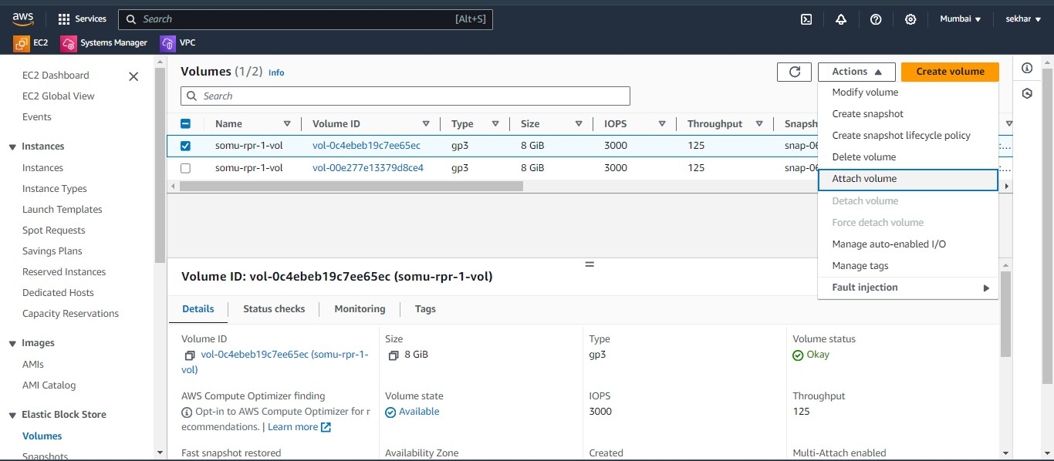

* Attach the volume.

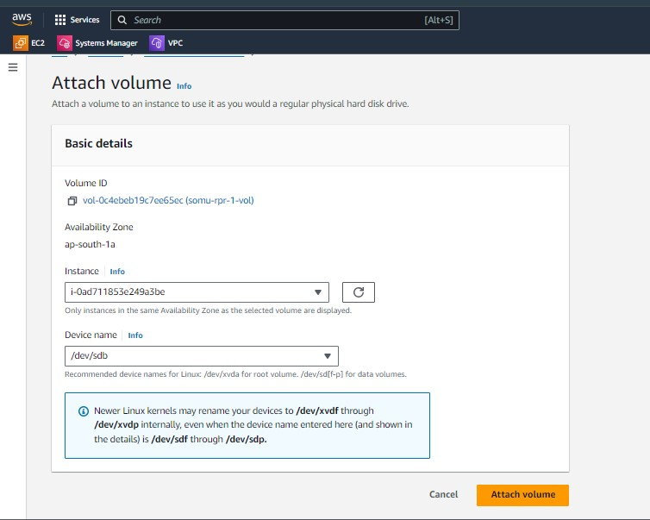

* Start the instance.

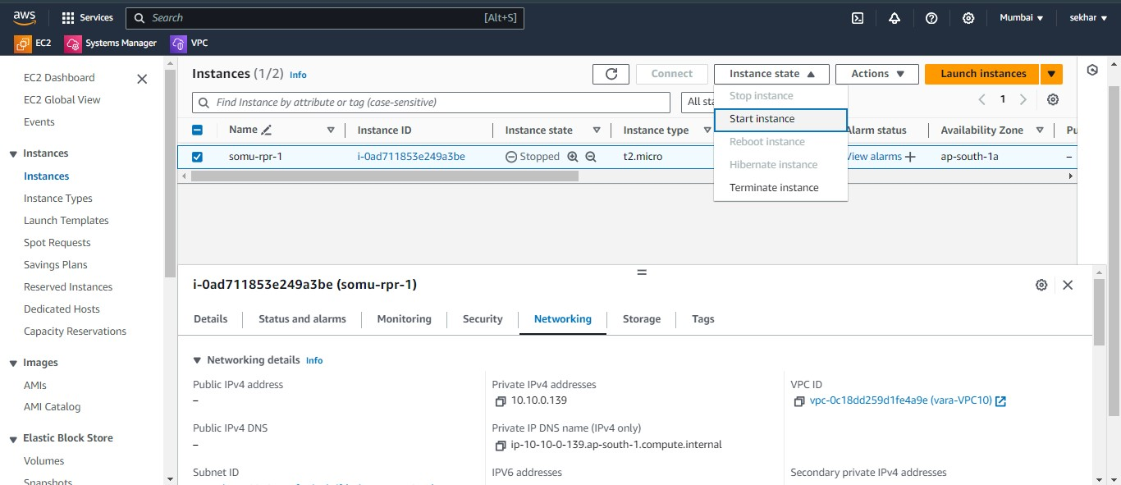

* Successfully instance started.

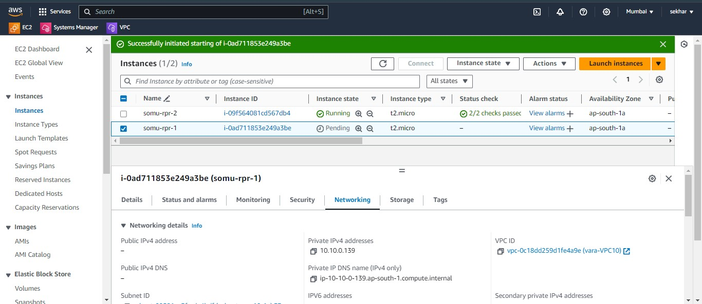

* Whenever it is public ip will be visible.
* Go to putty and login to root user and change password.
* Successfully login.